Paul Collado
CSC-208-60
Sept 20, 2010
Label

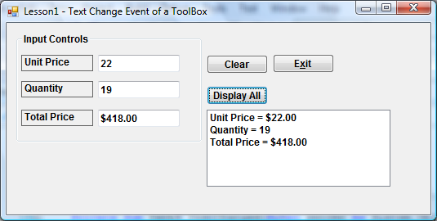

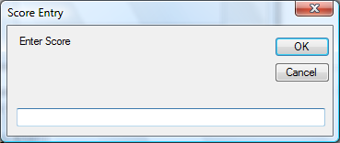

Public Class FrmLesson1

Private Sub GroupBox1_Enter(ByVal sender As System.Object, ByVal e As System.EventArgs) Handles GrpAny.Enter

End Sub________________________________________________________________________

Private Sub BtnExit_Click(ByVal sender As System.Object, ByVal e As System.EventArgs) Handles BtnExit.Click
Me.Close()
End Sub

Private Sub BtnClear_Click(ByVal sender As System.Object, ByVal e As System.EventArgs) Handles BtnClear.Click
Me.TxtQty.Clear()
Me.TxtUP.Clear()
Me.TxtTotPrice.Clear()
Me.TxtUP.Focus()
End Sub________________________________________________________________________

Private Sub TxtUP_TextChanged(ByVal sender As System.Object, ByVal e As System.EventArgs) Handles TxtUP.TextChanged
Dim UP As Decimal, Quantity As Integer, TotPrice As Decimal
UP = Val(Me.TxtUP.Text)
Quantity = Val(Me.TxtQty.Text)
TotPrice = (UP * Quantity)
Me.TxtTotPrice.Text = FormatCurrency(TotPrice)

End Sub________________________________________________________________________

Private Sub TxtQty_TextChanged(ByVal sender As System.Object, ByVal e As System.EventArgs) Handles TxtQty.TextChanged
Dim UP As Decimal, Quantity As Integer, TotPrice As Decimal
UP = Val(Me.TxtUP.Text)
Quantity = Val(Me.TxtQty.Text)
TotPrice = (UP * Quantity)
Me.TxtTotPrice.Text = FormatCurrency(TotPrice)

End Sub________________________________________________________________________

Private Sub BtnShow_Click(ByVal sender As System.Object, ByVal e As System.EventArgs) Handles BtnShow.Click
Dim A As Integer
Me.LstDisplayOutput.Items.Clear()
Me.LstDisplayOutput.Items.Add("Unit Price = " & FormatCurrency(Val(Me.TxtUP.Text)))
Me.LstDisplayOutput.Items.Add("Quantity = " & Val(Me.TxtQty.Text))
Me.LstDisplayOutput.Items.Add("Total Price = " & FormatCurrency(Val(Me.TxtUP.Text) * (Val(Me.TxtQty.Text))))
A = InputBox("Enter Score", "Score Entry")
Me.LstDisplayOutput.Items.Add("Score = " & A)
End Sub________________________________________________________________________
End Class

